Manu Patil

ISIM Fall 2018

31 August 2018

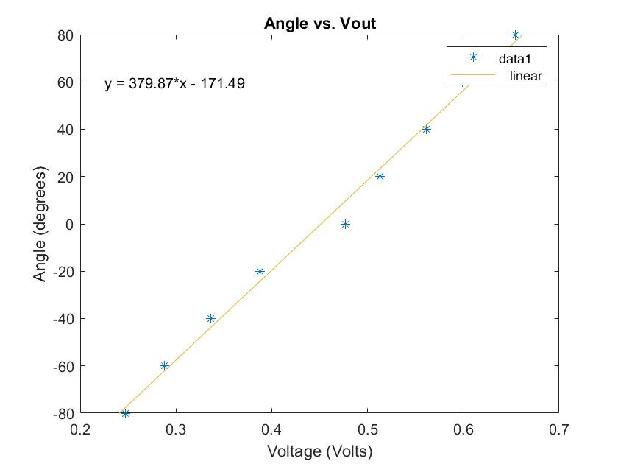

Figure 1: The graph above shows the relation between an input angle and the resulting output voltage

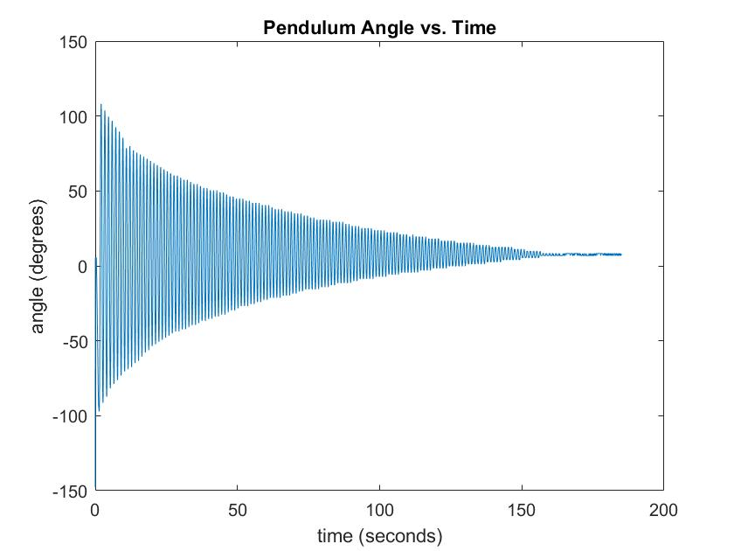

Figure 2: The graph above shows the relation of the pendulum angle from the rest position as time progresses